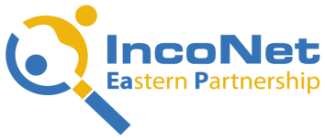

STI Cooperation Network for Eastern Partnership Countries (IncoNet EaP)

Training for Horizon 2020 National Contact Points in Eastern Partnership countries

Minsk, BELARUS, 14-15 April 2014
BonHotel, 2, Pritytskogo str.

Registration Form

1 | Title (Ms., Mr., Prof., Dr.)
2 | Family Name
3 | First Name
4 | Organisation / Company
5 | Position / NCP area
6 | Address
7 | Post Code / City
8 | Country
9 | Phone Number, mobile
10 | Fax Number
11 | E-mail Address

I need an official invitation to arrange participation in the training in my organization | yes | no

I require reservation of a room at a hotel in Minsk. Please specify dates of arrival/departure
Date of arrival to Minsk | Date of departure from Minsk | Single room | Other requirements on accommodation (please, specify)

Please fill in the form and return it as soon as possible but not later than 3 April 2014 by email to Ms Katherine Skuratovich, BelISA, skuratovich@belisa.org.by, tel/. +375 17 2094326.

